Exploring Game Development As a Branch of Software Development

Michael Watkins

CST-451: Senior Project I

Professor Amr Elchouemi

Revision 2

May 11, 2025

Abstract
This capstone project explores game development as a branch of software development, focusing on creating an interactive and engaging game using Java. The project aims to enhance technical skills in game programming while providing a portfolio-worthy product that demonstrates proficiency in design, debugging, and playtesting. Challenges include mastering advanced game development concepts and managing time effectively as a solo developer. The project will follow a structured timeline, ensuring iterative testing and improvement, with the goal of publishing the game on a distribution platform such as itch.io or Steam. Through this project, I seek to apply both technical expertise and craft an experience that is creative, innovative, and enjoyable for players.
Exploring Game Development As a Branch of Software Development
Prepared by Michael Watkins

Design Planning Summary
This development project is centered around the creation of a strategic, fast-paced card game using Java that reimagines the classic card game Egyptian Rat Screw with new mechanics, modern features, and an original scoring system. The game is being built as a solo capstone project for CST-451, with the goal of exploring game development as a viable branch of software engineering and showcasing technical skills in programming, design, and iterative development.
The idea for this project came from a long-standing personal interest in game design, as well as a recent revival of that interest through university coursework in Java and C#. After years of playing and creating small games for fun, this project offers an opportunity to go deeper by turning a familiar card game into something more complex, with added mechanics like power-ups, player progression, AI difficulty scaling, and a reward system. There wasn’t necessarily a “need” in the traditional business sense, but there was a clear personal and academic drive to take a creative concept and bring it to life as a functioning, polished product.
The main challenges being addressed by the project include developing game logic that balances strategy and randomness, implementing intuitive player controls and feedback mechanisms (like visual slap opportunities), and designing an upgrade and scoring system that rewards performance without being overly complex. The proposed solution is to combine traditional game mechanics with an original set of modifiers, such as Power Stickers, special cards, and unique slap triggers, to increase replayability and challenge.
The rationale behind this approach is to apply programming and problem-solving skills in a project that’s both technically engaging and creatively fulfilling. It also provides an ideal platform for learning advanced Java concepts like state management, event handling, and object-oriented architecture in a fun, real-world context.

Overview of Design Concepts
This project proposes the development of a Java-based card game that reimagines the classic Egyptian Rat Screw with strategic upgrades, evolving difficulty, and player customization. The game will follow a clear, cyclical loop of turns and scoring rounds, with a progression system and reactive AI opponents. The solution design reflects a modular, object-oriented approach and leverages clear process flow as outlined in the attached diagrams.
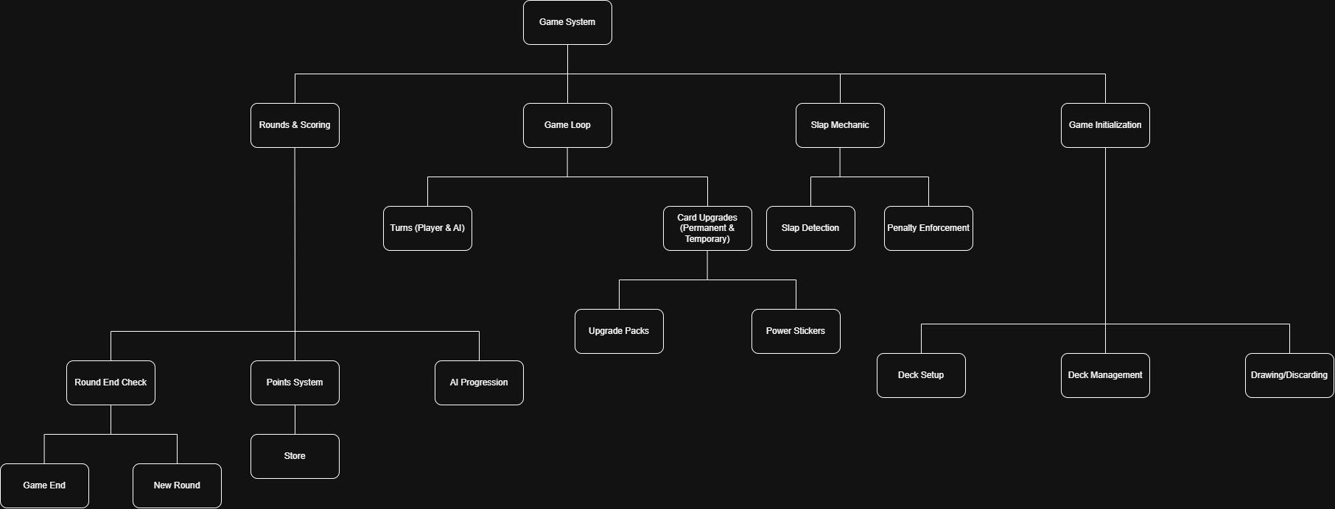
Figure 1: The system design for this project.

The System Design Diagram segments the game into key modules:
- Game Initialization handles deck setup, card drawing logic, and player hand management.
- Game Loop contains turn-taking logic (for both the player and AI), card play mechanics, and Power Sticker effects.
- Card Upgrades branch into temporary (Power Stickers) and permanent (Upgrade Packs), with each upgrade affecting card behavior or player abilities.
- A Slap Mechanic module that is responsible for slap detection and penalty enforcement, applying appropriate responses to player actions.
- Rounds & Scoring module includes round-end conditions, scoring calculations, and post-round shop interactions.
- AI Progression ensures that AI players gain complexity and reaction speed with each new round, scaling the challenge gradually.
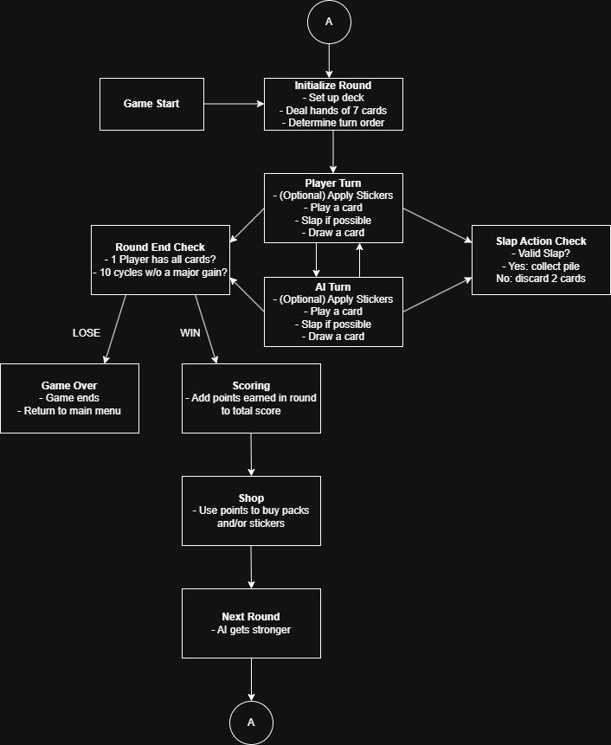
Figure 2: The System Logical Model for this project.

The attached System Logical Model outlines the full gameplay loop:
- The game begins with round initialization, where the deck is shuffled, hands are dealt, and turn order is determined.
- Players and AI take alternating turns, during which they may apply Power Stickers (temporary card boosts), play a card, slap if eligible, and then draw a card.
- Slap actions are checked against defined conditions (Joker played, quads, or exact match). If valid, the pile is collected; if invalid, the player discards two cards.
- After each cycle of play, a Round End Check evaluates if one player has all cards or if the cycle cap has been reached (10 cycles without a player gaining 15 or more cards).
- If the player wins, their score is tallied and they enter the Shop to use points on card packs and stickers.
- If the player loses a round, the game ends and they return to the main menu.
- With each new round, AI behavior increases in difficulty—getting faster at slapping or using power stickers.

ID | Deliverable Description | Comments | Evaluator (Internal/External) | Status | Date of Decision
1 | Initial Game Prototype | Includes basic turn structure, deck setup, and the slap mechanic | Internal | In Progress | 6/14/25
2 | Full Game Loop Implementation | Round tracking, win/loss conditions, scoring, and player turns | Internal | In progress | 7/14/25
3 | Upgrade and Sticker System | Players can collect, apply, and interact with power-ups and modifiers | Internal | Planned | TBD
4 | AI Behavior and Scaling Logic | Adds AI opponent logic and progression between rounds | Internal | Planned | TBD
5 | Final Playable Build for Showcase + itch.io Distribution Page | Polish, debugging, and finished game hosted on a public platform | Internal/External | Planned | August 2025

Detailed Solution Architecture
Object Model Overview

Class Name | Description
GameManager | Controls the game loop and transitions between game states.
Card | Represents individual cards with suit, value, and upgrade data.
Deck | Manages center deck and personal draw piles
Player | Abstract class used by both HumanPlayer and AIPlayer.
HumanPlayer | Extends Player, handles user input and slap attempts.
AIPlayer | Extends Player, handles AI logic and slap reactions.
Sticker | Represents temporary card modifiers.
UpgradePack | Represents permanent deck/card enhancements.
SlapDetector | Detects valid slap conditions based on pile state.
Shop | Manages purchase logic for upgrades and stickers.
RoundManager | Evaluates round-end conditions and manages transitions between rounds.

Use Cases

Use Case | Actor | Description
Play Card | Human/AI | Player selects or AI automatically plays a card from hand.
Attempt Slap | Human/AI | Actor attempts to slap the pile when conditions are met.
Purchase Upgrade | Human | Player spends points to purchase upgrade packs or power stickers.
Apply Power Sticker | Human/AI | Applies temporary stickers before card play for enhanced effects.
Win/Lose Round | GameManager | System checks for round-end conditions and declares the outcome.
Game Progression | GameManager | Advances to the next round of play and increases AI difficulty.

UI/Screen Specifications

Screen Name | Components Introduced
Main Menu | Start Button, Exit Button, Options
Gameplay Screen | Player hand, center draw pile, slap button, AI hand area, personal/AI draw piles, center discard pile
Shop Screen | Available upgrades, points balance, buy buttons
Round Summary | Score display, outcome message, Continue/Exit buttons

Integration Points:
- Player input events (mouse click or key press for slaps)
- Graphics engine or library (Java Swing or JavaFX)
- Persistence: Saving high scores, in-progress game states/scores, and/or unlocked upgrades to local file
No existing systems will be modified; this is a stand-alone game project.
Conversion: Not applicable; the game uses its own self-contained logic and rules.

Solution Configuration Changes:
- Java JDK 21
- Eclipse IDE
- Swing/JavaFX for GUI
- Local file storage for scores or deck states

System Security Considerations:
Security measures are not directly relevant to this game since it is a local-only, single-player application with no user authentication, sensitive data handling, or networking involved.
However, if features like score saving or online publishing are planned and added later, basic precautions will be considered:
- Input validation for user interactions
- Limiting file system access scope for save/load
- Avoiding unsafe reflection or serialization practices

Hardware and Software Technologies
1 - Java Development Kit (JDK) 21
2 - Eclipse IDE
3 - Java Swing / JavaFX for UI Development
4 - Windows/Mac/Linux-compatible desktop hardware (For this project I will be using a Windows PC)
5 - Git (for version control and backup management)

Revision and Sign-off Sheet
Change Record
Date | Editor | Revision Notes
4/12/25 | Michael Watkins | Final Plan Created

Overall Instructor Feedback and Comments

